Supplemental Staff Report
Meeting Date: November 7, 2023
To: Siskiyou County Board of Supervisors
From: Bernadette Cizin, Associate Planner
Subject: Proposed Outpost M-R, LLC Agricultural Preserve Amendment, Williamson Act Rescission and Re-entry (APA-23-12) and CEQA Determination

Background and Discussion
On September 19, 2023, staff brought before the Board an Agricultural Preserve amendment project which proposes to rescind and reissue Williamson Act Contracts due to a minor Boundary Line adjustment, transferring 2.15 acres from a parcel under one contract to another. During the review process it was found that a portion of Resultant Parcel 2 (193.7-acres) is not within an Agricultural Preserve. Staff recommended that the Board consider the inclusion of the 193.7 acres not be considered a significant increase and adopt resolutions amending the Ag Preserve and rescinding and reissuing the contracts. After board discussion, the hearing was continued to October 3, 2023.
Staff presented the project on October 3, 2023 with no change to staff’s recommendation and notified the board that the applicant team had requested the hearing be continued to November 7, 2023. After board discussion, the Board directed staff to gather more information regarding soils and flood hazard areas of the property proposed to be added to the Ag Preserve and estimated loss in tax revenue. The public hearing was continued to November 7, 2023.
Additional Information Requested
- Soils – as directed by the board, staff analyzed the soils of the 193.7 acres that are recommended to be added to the Ag Preserve.
Planning Response: The 193.7 acres alone could qualify for an individual agricultural preserve as the land contains approximately 42.66-acres of Class I or II equivalent soils as shown in the table below and in the attached NRCS soils data.

Soil Type | Acres +/- | Class | Ratio to Class I | Equivalent
28 | 1.2 | VI | 6:1 | .2
105sc | 32.9 | IV | 4:1 | 8.2
144sc | 1.6 | VII | 10:1 | .16
105 | 80.6 | IV | 4:1 | 20.15
122 | 17 | III | 2:1 | 8.5
123 | 6.3 | III | 2:1 | 3.15
143 | 2.5 | VII | 10:1 | .25
144 | 1.3 | VII | 10:1 | .13
213 | 31 | VIII | 0 | 0
237 | 19.2 | VII | 10:1 | 1.92
Total | 193.7 |  |  | 42.66

- Flood Plain – as requested, below is a map of the subject property, showing approximately 74 acres of the 193.7 acres proposed to be added to the Preserve, within the FEMA mapped flood plain.

Planning Response: Planning has no comment regarding the property within the flood plain as it relates to whether the property qualifies for Williamson Act Contract.

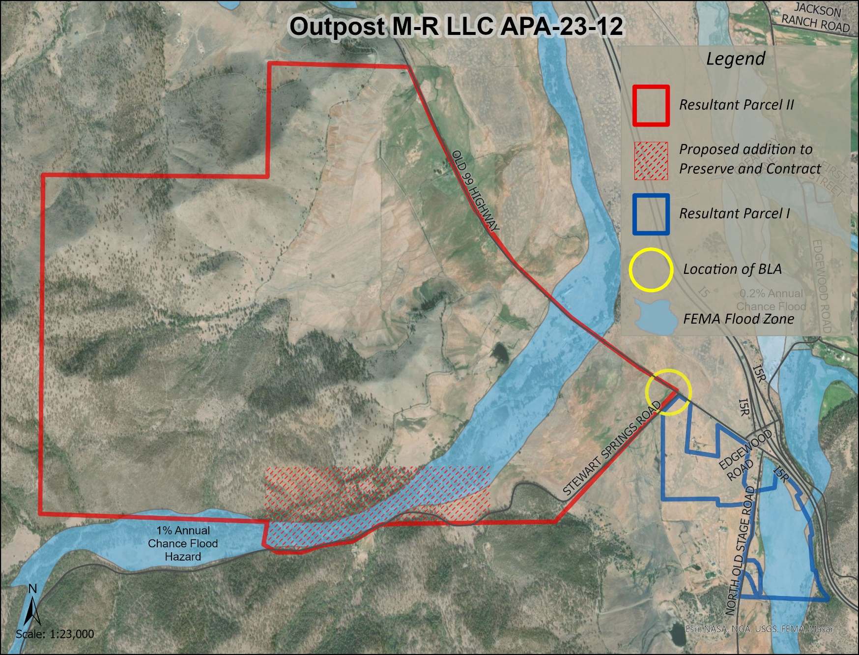
Figure 1: Project map
- Loss in tax revenue – The comment provided by the Assessor and included as Exhibit D to the September 19, 2023 Staff Report, provides tax valuations. The board requested a breakdown of that information to detail the loss of tax revenue to the general fund, should the 193.7 acres be included in the Ag Preserve, as recommended.

APN | XIIA Values | Ag Preserve Values | Loss of Tax Revenue | Loss To General Fund
020-160-181 | $167.31 | $8.64 | $158.67 | 33.32
020-160-190 | $631.35 | $145.00 | $486.35 | 102.13
020-130-021 | $399.33 | $11.00 | $388.33 | 81.55
Total Annually |  |  |  | $217.00

Planning Response: Utilizing the formula provided by the County Assessor, (XIIA Values minus Ag Preserve Values equals the total loss in tax revenue, with General Fund revenue calculated at approximately 21% of the total tax revenue) the total Loss to the General Fund, should the 193.7 acres be included in the Ag Preserve, is approximately $217.00 annually.

Comments
No comments were received as of the preparation of this staff report.

Analysis
The property meets the requirements for acreage, soils and use according to the Rules for the Establishment and Administration of Agricultural Preserves and Williamson Act Contracts. The property historically has been used for and continues to be used for livestock grazing.

Environmental Review
Staff recommends that the proposed project be considered categorically exempt from the California Environmental Quality Act (CEQA) pursuant to CEQA Guidelines Section 15317, Open Space Easements or Contracts. A Categorical Exemption implies that the project will not result in any significant adverse environmental effects. CEQA Guidelines Section 15317 specifically exempts the making and renewing of open space contracts under the Williamson Act, which is applicable to the subject action.
The Board of Supervisors must consider the proposed CEQA exemption together with any comments received during the public review process. Further, the exemption can only be approved if the Board finds, based on the whole record before it, that there is not substantial evidence that the project will have a significant effect on the environment. Accordingly, a finding to this effect has been incorporated into both draft resolutions prepared for the Board’s consideration.

Recommended Action
Should the Board of Supervisors concur with staff’s analysis, staff recommends that the Board of Supervisors find that the proposed modifications to the Williamson Act contracts, and Agricultural Preserves are exempt from CEQA and approve said modifications.
A draft motion to this effect is provided below.

Recommended Motions
I move to take the following actions:
- Determine the project exempt from CEQA in accordance with Section 15317, Open Space Easements or Contracts; and
- Adopt the attached resolution approving amendment to the existing Agricultural Preserves and establishment of a new preserve which includes the 193.7 acres previously not within a preserve; and
- Adopt the attached resolution approving the rescission and reentry of the applicable Williamson Act contracts which includes the 193.7 acres previously not encumbered by Williamson Act Contract; and

Exhibits to the Staff Report
- NRCS Soils Data

